Christina Karklin
Reflection of a polygon-Geogebra
3/9/17

- Go to geogebra.com and open a new file by clicking on the plus sign on the top of the page, and selecting Start GeoGebra from the dropdown box. Then, your graph should appear with axes and grid lines. If you do not have either of these, right-click on the graph and check the boxes for “Axes” and “Grid.”

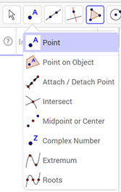
2. To create our polygon, we need to plot points. To plot our points, we need to click on the symbol at the top that has a dot, and the letter “A”. Then, select “Point” from the dropdown box.

We are going to plot the points:
(1,1) (3,4) (5,1)

3. To connect the points and create a polygon, we need to click on the symbol on the top of the page that looks like an orange triangle. Then click on the first option in the dropdown box which says “Polygon.”
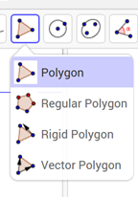

To create the polygon, click from one point to another until all points are connected.
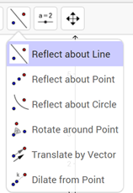
4. We want to reflect our polygon about the x-axis. To do this we need to click on the icon on the top of the page that has two dots with a line in between them. From here, we can click on the first option from the dropdown box which says “Reflect about a Line.”

To complete the reflection, we need to first click on the polygon, and then on the line which we wish to reflect the polygon over. So, click on the polygon and then click on the x-axis. Then, we should be able to see our reflection.

5. If you are having trouble seeing your reflection, you can move the grid by clicking on the last icon on the top of the page that looks like a cross with arrows on each end. Then click on the “Move Graphics View,” “Zoom In,” or “Zoom Out” in the dropdown box. If you have selected “Move Graphics View,” then click on the graph and move your mouse up/down or left/right until you have a good view.

Our new points are:
(1,-1) (5,-1) (3,-4)

What values changed? __________________________________________

Let’s do another reflection over the y-axis this time!

6. To start a new graph, click on the icon that is three parallel lines all the way to the right, on the top of the page. Then click “New” from the dropdown menu and do not save the previous graph. A new graph should appear on your screen. Click on the icon with the dot and the letter “A” and select the option “Point” from the dropdown menu to plot the points
(1,1) (3,-1) (1,-3)

7. To create a polygon from these points, click on the symbol that looks like an orange triangle and select “Polygon” from the dropdown menu. Then, click from one point to another until all of the points are connected.

8. To reflect over the y-axis, we need to click on the icon that has 2 dots with a lone in between them and select “Reflect about Line” from the dropdown menu. Then, click on the polygon first and then the y-axis second. After clicking on the y-axis, you should see the reflection of our polygon.

Our new points are:
(-1,1) (-3,-1) (-1,-3)

What values changed? ________________________________________

What if we are not reflecting over an axis, but a line? Let’s try one with the line x=6!

9. Create a new graph by clicking on the icon that has three parallel lines all the way to the right on the top of the page. Don’t save the previous graph. Click on the point icon and plot the following points:
(2,0) (4,2) (3,-3)

Connect the points to create a polygon by clicking the icon that looks like an orange triangle and choosing “Polygon” from the dropdown menu. Then click from one point to another until all of the points are connected.
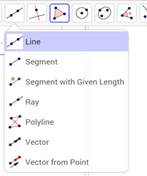
10. Click the icon that has two dots with a line in between them and select “Reflect about Line.” To reflect about the line x=6 we first need to create a line. Click on the icon that looks like a line with two points on it and select “Line” from the dropdown menu.

11. Then click on the point (6,0). You can see the line is free moving, so we need to click on another point to create the line. Click any pint on the line y=6 to get the line to stop moving. For example, (6,2).

12. Then we will click on the icon that looks like two dots with a line in between them and select “Reflect about Line: from the dropdown menu. The click on the polygon, and then click on the line y=6 that we created. You should see the reflection.
Our new points are:
(10,0) (8,2) (9,-3)

What values changed? ___________________________________________

Try some reflections of polygon on your own!

