Christina Karklin
The Distributive Property
4/28/17

Goal: The students will understand the concept of the distributive property.

Objective: Given Distributive Property at the Movies! worksheet, the students will work in groups of 2-3 to create expressions involving the distributive property and evaluate them correctly with 85% accuracy.

Definition: The distributive property lets you multiply a sum by multiplying each addend separately and then add the products.
a(b+c)=ab+ac
Distributive Property at the Movies!!!
Combo 1  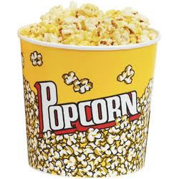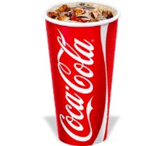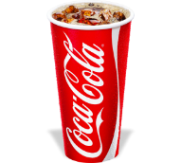 | Combo 2  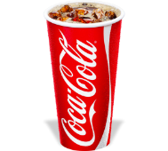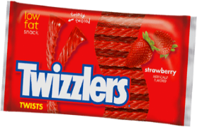
Combo 3  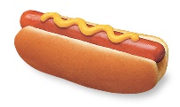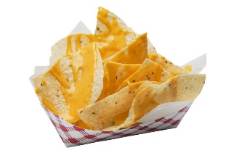 | Combo 4  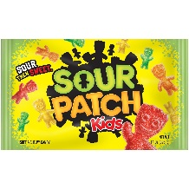
Popcorn=P Coca-Cola=C Sour Patch Kids=S Hotdog=H Nachos=N Twizzlers=T

Example 1: I would like 2 of Combo 1, please.

Step 1: Look at how many of each item are in the combo and write this in parentheses using addition to separate the items.
In Combo 1, there’s 1 popcorn and 2 Coca-Cola’s.
(1P+2C)

Step 2: Put how many of that combo you would like to order in front of the parentheses.
2(1P+2C)

Step 3: Draw arrows to show the distributive property.

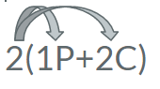
Step 4: Multiply to find the solution.
2x1P=2P + 2x2C=4C
2P+4C
Step 5: Write a sentence.
I will have a total of 2 popcorns and 4 Coca-Colas.

Example 2: I would like 3 of Combo 3, please.

Example 3: I would like 3 of Combo 4, please.

Example 4: I would like 3 of Combo 1, please.

Example 5: I would like 4 of Combo 2, please.

Example 6: I would like 2 of Combo 4, please.

Example 7: I would like 3 of Combo 2, please.

References:

Distributive Property Definition. (n.d.). Retrieved April 30, 2017, from
http://www.mathwarehouse.com/dictionary/D-words/distributive-property -definition -and-examples.php

Hines, E. (2013, January 04). Distributive Property Combo Meal Activity. Retrieved April 30,
2017, from https://www.teacherspayteachers.com/Product/Distributive-Property-Combo- Meal-Activity-477881

